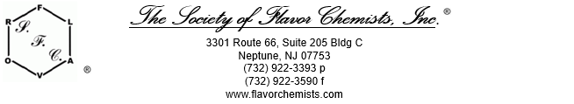

2025 Jogue Inc. Scholarship Award



The Society of Flavor Chemists, Inc. awards a $2,000 scholarship to a student who is currently in a graduate degree program in one of the allied disciplines of the flavor industry.

Eligibility Requirements
You are eligible to apply for this award if each of the below statements are TRUE.
- I am currently enrolled full-time in an accredited graduate degree program.
- I am currently enrolled part-time in an accredited graduate degree program and actively employed in the flavor industry.
- I am currently enrolled in a program specifically related to the flavor industry (including, but not limited to, chemistry, biology, food science, nutrition, microbiology, engineering, business, or marketing).

Important Dates
- Deadline for submission is February 21, 2025.
- Award recipient will be notified by March 7, 2025.
- Award recipient will be presented at the Society of Flavor Chemists Annual Meeting in Newark, NJ on May 8, 2025.

JOGUE SCHOLARSHIP APPLICATION

Applicant Information

Name |  | First |  |  |  |  | Middle |  |  |  |  | Last
Home Address |  | street address |  |  |  |  |  |  |  | city
 |  | state / province / region |  |  |  |  |  |  |  | country
Phone |  |  |  |  |  | Email
College/University
School Address
Major |  |  |  |  |  |  |  |  |  |  | Degree Pursued |  | ☐ MS ☐PhD
Current Academic year |  |  |  |  | Expected year of graduation |  |  |  |  |  |  |  |  | Grade Point Average

Educational History

Education | Name of School | Diploma/Degree Received | Year Received
High School
Baccalaureate
Graduate
PhD / Doctorate
Other
Please provide the following information.
Elaborate as you feel necessary. Include your name on all paperwork submitted.

- What are your career goals?

- List research, publications, awards, honors received with dates.

- List posters and/or presentations shown at meetings or conferences.

- List extra-curricular activities. Include dates and offices held.

- Include an abstract of graduate research that would be presented at the Society of Flavor Chemists Annual Meeting in May (if selected).

- Please attach a copy of your transcript, detailing course work completed to date.

- Please attach a recommendation letter from a professor, instructor, counselor, or workplace supervisor.

- Please explain why you should be chosen for this award.

Applicant’s Signature |  | Date

Please create a pdf of the completed application form and email it along with the required attachments to scholarship@flavorchemist.org.

SUBMIT APPLICATION

